Josiah Evans
jge842
EECS 351
Project B
“Wobbly Jello Tower”

For the Wobbly Jello Tower, I wanted to create a 3D space with a fully controllable camera, and populate the space with interesting objects. To operate the fully controllable camera, you can use the w and a keys to move forward and backward in the direction you are facing, and the a and d keys to move left and right relative to the direction you are facing. To move up and down, you may hit the space and control keys respectively. To turn the camera, you may hit the corresponding arrow keys. To switch between perspective and orthographic views in the upper right viewport, you may hit the enter key. These controls allow you to independently translate the camera and rotate the camera, without one interfering with the other.

To change the objects in the simulation, there are two controls. The first is activated by hitting the f key, which will increase the maximum amount the jello tower will curl, and also affect the pulsing of the cubic “Sun” floating above the ground. If you wish to stop the tower from curling and the sun from pulsing, you may hit the g key until the movement ceases. Pressing the g key further will reverse the direction of the curling tower, and reverse the direction of the sun's pulsing.
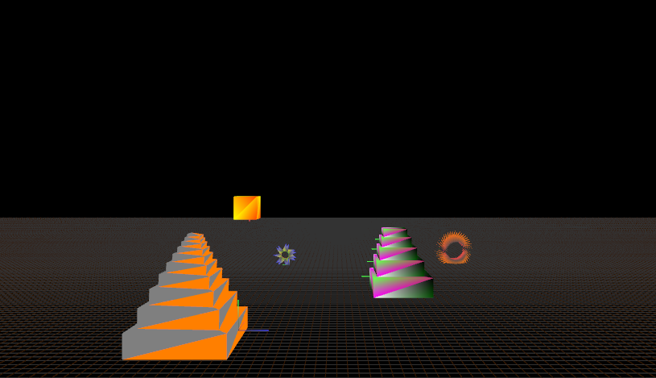
Fig. 1 An overview of the scene

To populate the 3D space with interesting objects, I placed 5 items. The first item is the wobbling jello tower. This item consists of many jointed segments which slowly accumulate an angle and curl back and forth. The second item is similar to the wobbling jello tower, but is fixed in place and colored more like a cake. The third item is a pulsing sun, with yellow, orange, and red-orange hues to simulate a time near sunset. The fourth item is a flower pedal ring, not dissimilar from a lotus. The fifth item is a star with a circular center and many radial fans, created to represent the future of many possibilities. These items are all different colors, shapes, and sizes, and present an interesting space where the camera can travel.
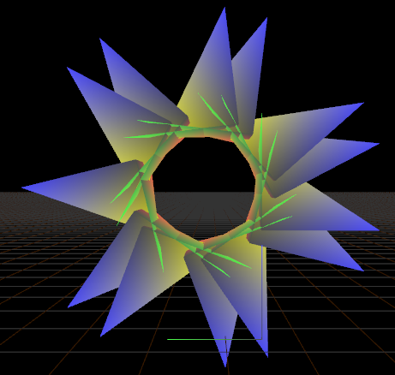
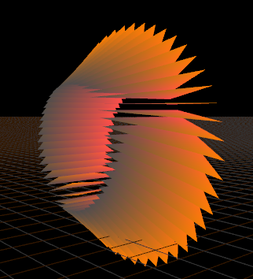
Fig 2. A lotus flower. Note the drawing axis in the bottom right.

Fig 3. The future. Note the increasing size indicating divergent paths.
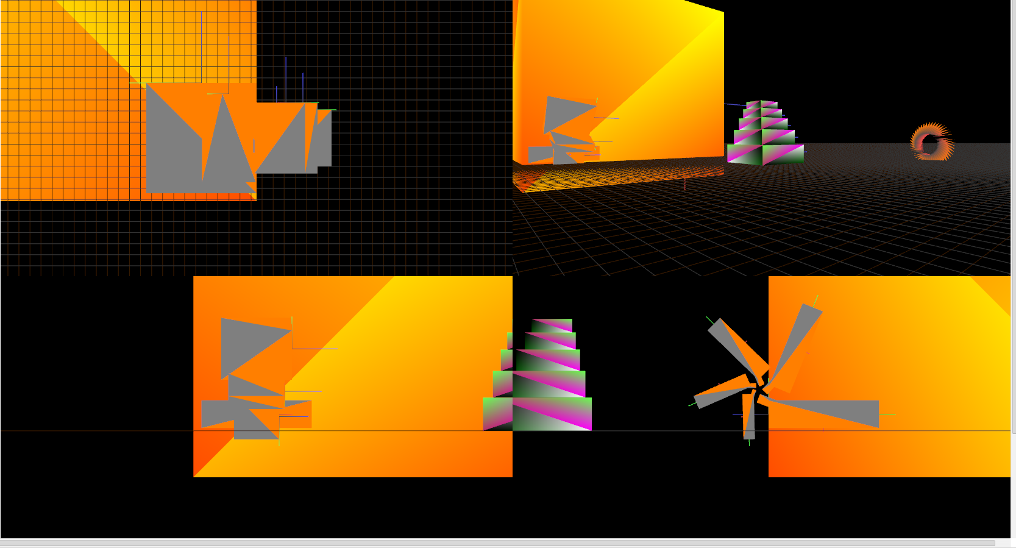

Fig 4. Chaos ensues if you hold down the f key. Note the extreme size of the sun and extreme curl of the tower.

